**Project Title – “Smart Subscription Tracker”**

**PHASE 2 - Org Setup & Configuration**

* **Company Profile Setup**

Set basic org details under *Setup → Company Information → Edit*:

* **Name**: Project/Org name (e.g., *Smart Subscription Tracker – Dev*).
* **Time Zone**: Default working timezone (e.g., *GMT+05:30 Kolkata*).
* **Locale**: Controls date/number formats (e.g., *English (India/US)*).
* **Language**: Default UI language for new users.
* **Currency**: Corporate currency (e.g., *INR, USD*).

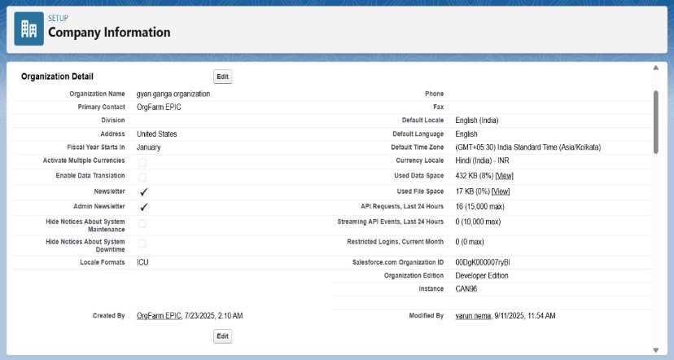

* **Business Hours Setup**

Configure working hours for escalation rules and SLA tracking:

* **Path**: *Setup → Business Hours → New*.
* **Name**: Define (e.g., *Standard Business Hours*).
* **Time Zone**: Select org or regional timezone (e.g., *GMT+05:30 Asia/Kolkata*).
* **Working Hours**: Set daily schedule (e.g., Mon–Sat 9:00 AM–6:00 PM; Sunday closed).
* **Save**: Apply as default if needed.

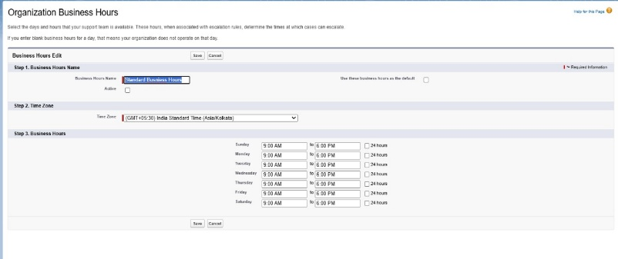

* **Fiscal Year Setup**  
  Defines reporting boundaries for forecasts and opportunities.
* **Path**: *Setup → Fiscal Year*.
* **Type**: Choose *Standard Fiscal Year* (Jan–Dec) or *Custom Fiscal Year* if months differ.
* **Configuration**: Select the starting month (e.g., *January*).
* **Save**: Apply settings to define fiscal periods.

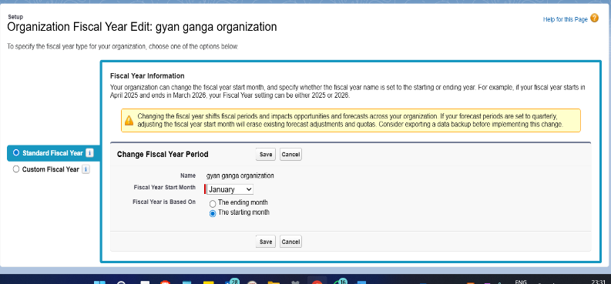

* **User Setup (Profiles, Roles, Permission Sets, Users)**
* **Profiles**: Cloned standard profiles to create custom ones for baseline access.
  + *Sales_Profile, Finance_Profile, Manager_Profile* (to be tuned later with object permissions).
* **Roles**: Defined role hierarchy for access and reporting.
  + *Manager, Sales Rep, Finance*.
* **Permission Sets**: Created *Payment_Access_PS* for Finance (object permissions to be added once Payment object exists).
* **Users**: Added sample users with respective profiles and roles.
  + *sales1* → Sales_Profile, Role: Sales Rep
  + *finance1* → Finance_Profile, Role: Finance
  + *manager1* → Manager_Profile, Role: Manager

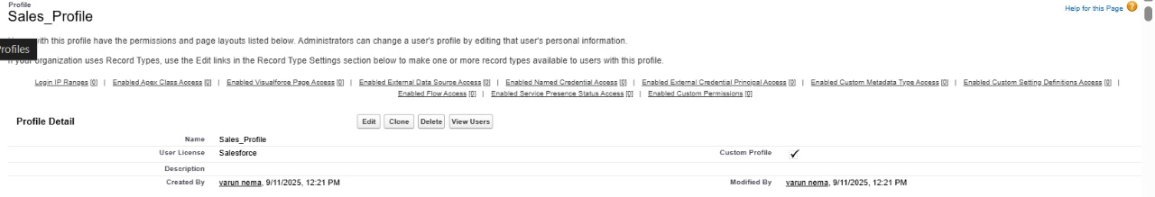

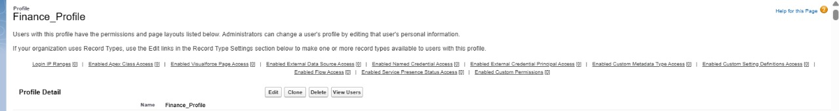

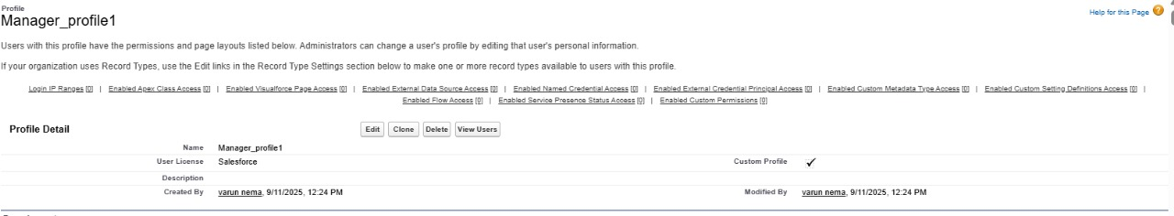

* **Role Hierarchy Setup**  
  Defines data visibility and reporting structure within the org.
* **Path**: *Setup → Roles → Set Up Roles*.
* **Top-Level Role**: *CEO* (root of hierarchy).
* **Manager Role**: Added as child of CEO.
* **Sales Rep Role**: Added as child under Manager.
* **Finance Role**: Added as sibling under Manager (or directly under top-level as needed).

**Resulting Hierarchy (example):**  
CEO → Manager → Sales Rep

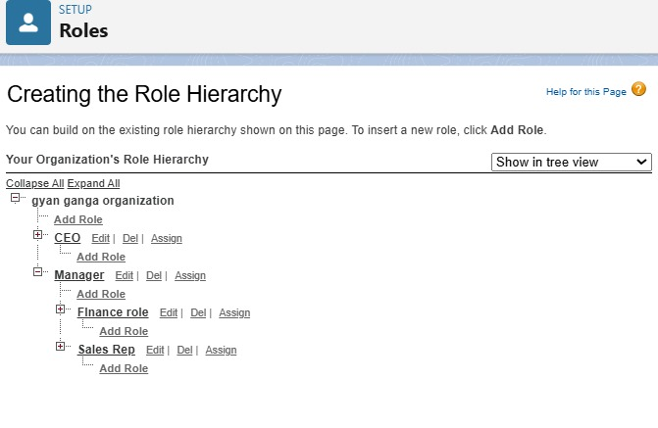

* **OWD (Org Wide Default)**

**This has to be done in the Phase 3, as the OWD setting are needed to be applied on an object which will be implemented in next phase of the project.**

* **Sharing Rule**

**This has to be done in the Phase 3 as well considering it has to be implemented on an object.**

* **Assign Permission Set(s)**

After creating users, assign the permission set for finance (when Payment object exists):

Setup → Quick Find → Users → click the finance user → Permission Set Assignments → Edit Assignments → add Payment_Access_PS → Save.

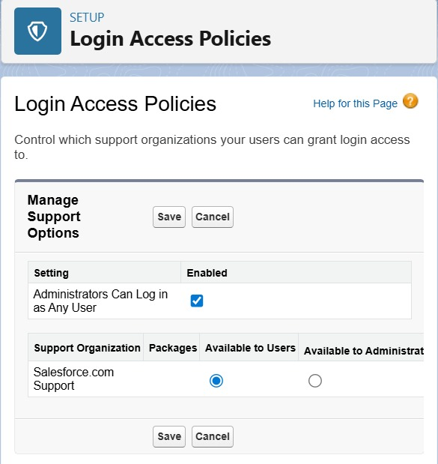

* Dev Org Setup

• To implement the following project a Salesforce Developer Edition org was setup.

• Made a GitHub Repository for source control.

• Setting up the VS Code and SFDX for the implementation of the LWC Component for development.